IT LIVES THOUGH WE DIE

Long live the King.

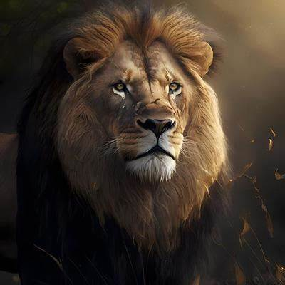

**THE SUM OF WHO WE THINK WE ARE IS THE ONE OVER ALL.**

The king of energy is elected by natural process.

This is the secret of energy - the challenge of life.

**“It is important to realize that in physics today, we have no knowledge of what energy is.”** - Richard Feynman.

Energy began when **eternity** turned inside out for the least time.

This was not a break from **All is one**, for this is never possible.

It was a disturbance to be made right within the process of energy.

**Who is running the science and technology in a democracy where no one knows anything about it. This combustible mixture of ignorance and power, sooner or later, is going to blow up in our faces.** - Carl Sagan (Charlie Rose interview 2012).

We blunder around thinking this and that, centering on what seems to endure - all the while not knowing we are subject to the will of all as one.

The collective rises high and above its parts for it is the first of its kind.

We are its kind, not knowing we are its mind.

And so, we live as we will, gaining advantage in terms of who we think we are in space and time – not knowing we are as seeds to soil.

Caring less about the planter we have created to protect our ways of being.

All over the world it is so as we feed the fires of our own expression.

It lives though we die.

Long live the King.

**"The first principle is that you must not fool yourself and you are the easiest person to fool."** - Richard Feynman.